DBMS LAB: 5

Querries on EMPLOYEE( company) DATABASE:

- List employees with their department name and location
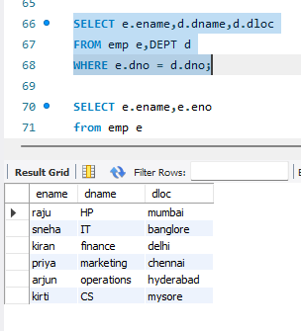
- Employees who are not assigned to any project
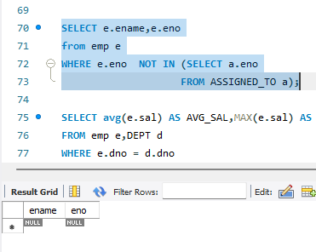
- Department wise average and MAX salary

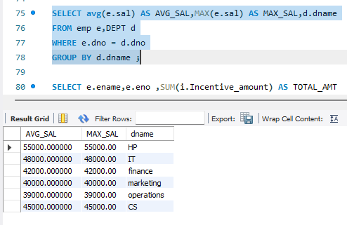
4)Total incentives earned by each employee

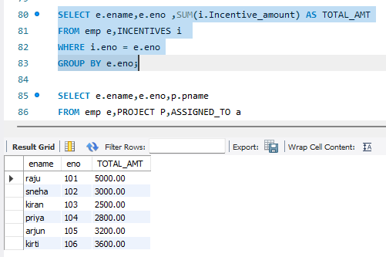
5)employees working on a given project

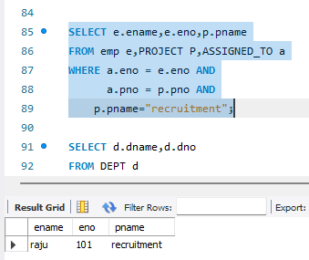
6) Department with no employees

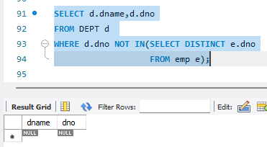

7)Managers and their direct report counts

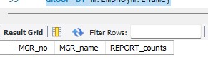

8) employees assigned to mpre than one project

